**Project Proposal**

**EN842004 Object Oriented Programming Project**

**1. Project name:** Riddles of the Tower of Mathematics

**ชื่อโครงการ:** ปริศนาแห่งหอคอยคณิตศาสตร์

**2. Contest topic:** Platform game

**3. Development Team**

**3.1. Project Leader**

Name: Thanakorn Prakobdee

Student ID: 643040625-6

Education Currently a second-year undergraduate majoring in Digital Media Engineering, Faculty of Engineering, Khon Kaen University

E-mail: [thanakorn_pr@kkumail.com](mailto:thanakorn_pr@kkumail.com)

**3.2. Member**

Name: Wachiraya Leelanusorn

Student ID: 643040814-3

Education: Currently a second-year undergraduate majoring in Digital Media Engineering, Faculty of Engineering, Khon Kaen University

E-mail: [wachiraya.l@kkumail.com](mailto:wachiraya.l@kkumail.com)

Name: Kamonlak Promsanthia

Student ID: 643040618-3

Education Currently a second-year undergraduate majoring in Digital Media Engineering, Faculty of Engineering, Khon Kaen University

E-mail: [kamonlak.p@kkumail.com](mailto:kamonlak.p@kkumail.com)

Name: Latthaphon Phoemmanirat

Student ID: 643040813-5

Education Currently a second-year undergraduate majoring in Digital Media Engineering, Faculty of Engineering, Khon Kaen University

E-mail: [latthaphon.p@kkumail.com](mailto:latthaphon.p@kkumail.com)

**4. Advisor**

**Name Assoc:** Prof. Dr. Kanda Saikaew

**Institute:** Khon Kaen University

**Contact**: Computer Engineering Department, Faculty of Engineering, KKU

**Phone**: 043-362-160

**E-mail**: [krunapon@kku.ac.th](mailto:krunapon@kku.ac.th)

**5. Key Words**

(Keywords) “GAME MATH FOR KIDs”

**A platform game** is a type of video game featuring two-dimensional graphics in which the player controls a character by jumping or climbing between solid platforms at different positions on the screen.

**Math** is solving math problems by using math operators.

**Kids** are children from 6-10 years old.

**6. Motivation**

Learning Disabilities (LD) is a common disorder in all countries around the world. According to epidemiology, 5 to 15% of school-aged children suffer from this disease. Statistically, it can be found in every room and every school by the distributional concept. If there are 50 children in the room, about 3-8 children with LD are found and 80 percent of LDs have reading disabilities. If it was a boy's school, there would probably be a higher chance of LD because guys are more likely to have LD than girls except for those who have problems calculating. In some studies, there were no gender differences for LDs. LD is divided into reading disabilities, writing disabilities, and disabilities in mathematics (Dyscalculia).

In this project, our group will focus on using media and technology to provide children with Dyscalculia with a new way of learning by developing a 2D platform game that combines math equations in grades 1-4 so the children with Dyscalculia can practice math skills and have fun as well.

ปัจจุบันเด็กที่ไม่ถนัดคณิตศาสตร์ในระดับประถมศึกษามีปัญหา เช่น เด็กบวก ลบ คูณ หาร เลขยังไม่แม่นยำ, บวก ลบ จำนวนตั้งแต่ 2 หลักขึ้นไปไม่ได้, แก้สมการไม่ได้ เป็นต้น ทำให้เด็กเหล่านี้ไม่สามารถประยุกต์คณิตศาสตร์กับชีวิตได้ เพราะคณิตศาสตร์อยู่ในชีวิตประจำวันของ เช่น การซื้อขายของ เป็นต้น

โดยกลุ่มของพวกเราจะเน้นไปทางการใช้สื่อ อุปกรณ์ สิ่งอำนวยประโยชน์แก้ไขปัญหา เพื่อให้เด็กที่มีวิธีการเรียนรู้ใหม่ โดยสร้างสื่อเป็นเกมที่ผสมผสานไปกับคณิตศาสตร์ ที่มีการเอาสมการคณิตศาสตร์ในระดับชั้นประถมศึกษาปีที่ 1-4 มารวมกับเกมที่เป็นแนว 2D เพื่อให้เด็กสามารถหาคำตอบได้ถูกต้องตามหลักเกณฑ์ทางคณิตศาสตร์และยังได้ความสนุกอีกด้วย

**7. Related Application**

|  |  |
| --- | --- |
| **รูปภาพประกอบด้วย ข้อความ, เวกเตอร์กราฟิก  คำอธิบายที่สร้างโดยอัตโนมัติ** | Super Marius World |
|  | Speed Math |

**8. Objectives**

So, children that have Learning Disabilities (LD) in mathematics can learn to solve problems according to mathematical guidelines.

* เพื่อให้เด็กสามารถหาคำตอบได้ถูกต้องตามหลักเกณฑ์ทางคณิตศาสตร์
* เพื่อสร้างเกมที่สามารถได้ทั้งความรู้และความสนุกไปในตัว

**9. Problems or benefits that are the reason why the program should be developed**

**9.1. Problems**

Children with Dyscalculia are often confused about numbers and cannot comprehend math operations. They have a hard time understanding numbers and learning math facts, including using math operations.

เด็กที่ไม่ถนัดเกี่ยวกับเรื่องตัวเลข ไม่เข้าใจเรื่อง การบวก ลบ คูณ หาร ทำให้ไม่สามารถหาคำตอบได้ถูกต้องตามหลักเกณฑ์ทางคณิตศาสตร์ และไม่สามารถใช้คณิตศาสตร์มาประยุกต์ใช้ในชีวิตประจำวันได้

**9.2. Benefits**

Children that have Learning Disabilities (LD) in mathematics can learn to solve problems according to mathematical guidelines.

เพื่อให้เด็กสามารถหาคำตอบได้ถูกต้องตามหลักเกณฑ์ทางคณิตศาสตร์

**10. Targets and Scope of the Project**

**10.1 Targets**

Children

**10.2 Scope**

Children from 6-10 years old.

**11. Methodology**

**11.1. Storyboard**

A boy named X accidentally touched a toy tower his father bought from a second-hand shop and became trapped inside a game called “Riddles of the Tower of Mathematics”. The only way he can escape is by solving mathematical problems inside the tower.

**11.2. Techniques and technologies for development**

unity package packages are collections of files and data from Unity projects, or elements of projects, which are compressed and stored in one file, similar to Zip files.

**11.3. Tools for development**

11.1. C#

C# is an object-oriented programming language developed by Microsoft that runs on the .NET Framework. It aims to combine the computational capabilities of C++ with the simpler programming of Visual Basic. C# is based on C++ and retains functionality similar to Java. Our group will use C# along with Unity to develop our game.

11.2. Python

Python is a programming language widely used in web applications, software development, data science, and machine learning (ML). Many developers use Python since it is more efficient, easy to learn, and can run on a wide variety of platforms. Python is free to download and integrates with all types of systems and increases development speed. We use Python to write Demo code for our game so we know how the game will work.

11.3. Unity

Unity is a cross-platform game engine that has many capabilities. The engine can be used to create three-dimensional (3D) and two-dimensional (2D) games (platform games), as well as interactive simulations and other experiences. The engine supports a variety of desktop, mobile, console, and virtual reality platforms. It is particularly popular for iOS and Android mobile game development.

11.4. Procreate

Procreate is an illustration, sketching, and painting app made exclusively for iPad that has many functions such as Digital painting, Animation, and 3D-model paintings. We use Procreate to illustrate backgrounds, game assets, and design characters.

11.5. Photoshop

Photoshop is an image creation, graphic design, and photo editing software with a variety of functions such as retouching, adjusting the light, adjusting the color, and adding various effects (Effect) to the picture, etc. We use it for making the effects and editing objects in the game.

11.6. GitHub

GitHub is a code hosting platform for version control and collaboration. It lets you and others work together on projects from anywhere. It works in the same way as Git, but it can be accessed and managed through the web without paying or installing every server to install Git itself. All the code and projects will be distributed to others to see. We share and edit the codes through GitHub in the group

11.7. visual studio code

Visual Studio Code is a source code editor. We use it to check programming accuracy before importing it to unity.

11.8. visual studio

Visual Studio is a program that helps develop software and systems which can communicate with computers to a certain extent but are still unable to develop the system itself. Suitable for VB and VB.NET. We will use it to write code for the movements of objects in the game.

11.9. Audio Library

Audio Library is the source for loading audio files for producing free video content that is copyright free. We use it to find sound effects for the game.

**11.4 Software Specification**

11.4.1. Design

|  |  |
| --- | --- |
|  | Menu |
|  | Choose Floor |
|  | Problem Display |

11.4.2. Flowchart

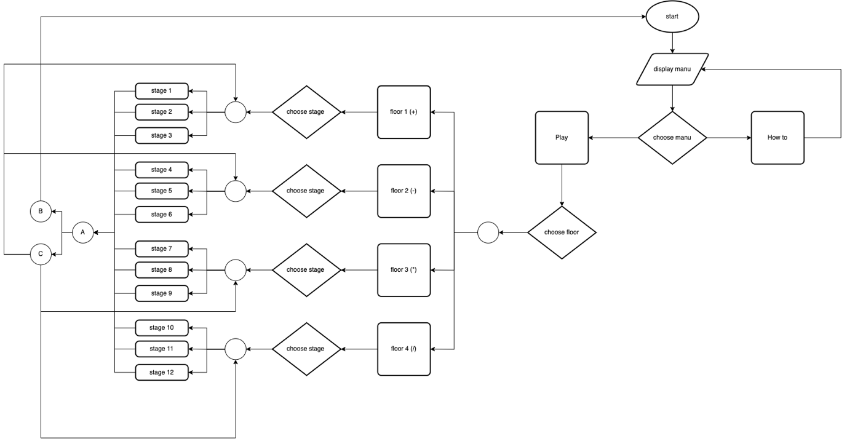

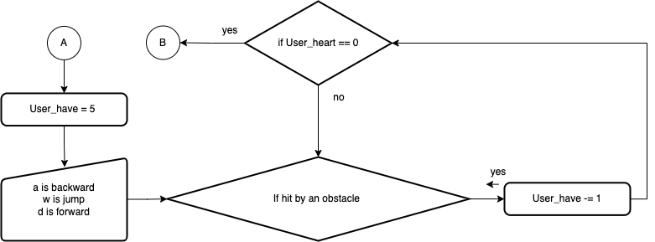 11.4.2.1. when hit by obstacles

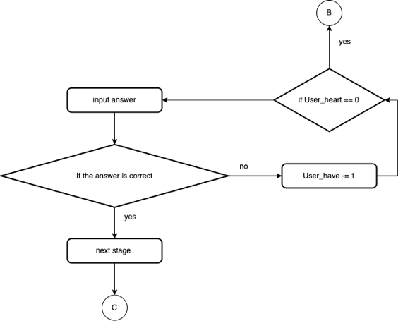 11.4.2.2. when he reached the gate of that stage

11.4.3. Limitations of the developing program

11.4.3.1. This game doesn't have a login system, so it doesn't store the scoreboard and the latest play stats. Allows the player to play whichever level they desire.

11.4.3.2. In the division stage, we set it to maximum divided by 2 in order to make it not too difficult for children.

**12.** **Bibliography**

ทวีศักดิ์ สิริรัตน์เรขา. (2560). แอลดี...ความบกพร่องทางการเรียนรู้. [Online]. Available URL:

happyhomeclinic.com/sp04-ld.htm.

“C# คืออะไร ซีชาร์ป คือ ภาษาคอมพิวเตอร์ ซึ่งพัฒนามาจากภาษา C++.” mindphp.com, 14 Mar.

        2017, [https://www.mindphp.com/คู่มือ/73-คืออะไร/2184-c-ชาร์ป-คืออะไร.html](https://www.mindphp.com/%E0%B8%84%E0%B8%B9%E0%B9%88%E0%B8%A1%E0%B8%B7%E0%B8%AD/73-%E0%B8%84%E0%B8%B7%E0%B8%AD%E0%B8%AD%E0%B8%B0%E0%B9%84%E0%B8%A3/2184-c-%E0%B8%8A%E0%B8%B2%E0%B8%A3%E0%B9%8C%E0%B8%9B-%E0%B8%84%E0%B8%B7%E0%B8%AD%E0%B8%AD%E0%B8%B0%E0%B9%84%E0%B8%A3.html).

“Python คืออะไร.” AWS, <https://aws.amazon.com/th/what-is/python/>. 8 Aug. 2022.

Mindphp Content Team. “โปรแกรม Unity คืออะไร.” mindphp.com, 27 Sep. 2021,

<https://www.>[mindphp.com/คู่มือ/73-คืออะไร/8286-program-unity.html](https://www.mindphp.com/%E0%B8%84%E0%B8%B9%E0%B9%88%E0%B8%A1%E0%B8%B7%E0%B8%AD/73-%E0%B8%84%E0%B8%B7%E0%B8%AD%E0%B8%AD%E0%B8%B0%E0%B9%84%E0%B8%A3/8286-program-unity.html).

พงศ์พฤฒานนท์,ปวรุตม์“GitHub คืออะไร และใช้อย่างไร.”  สำนักคอมพิวเตอร์มหาวิทยาลัย

        ศรีนครินทร์วิโรฒ, 24 Nov. 2021, <https://km.cc.swu.ac.th/archives/3606>.

“ใช้ส่วนขยาย Visual Studio Code.” Microsoft, 10 June 2022,

<https://docs.microsoft.com/th-th/power-apps/maker/portals/vs-code-extension>.

“Visual Studio วิชวลสตูดิโอ คืออะไร.” mindphp.com, 1 July 2016, <https://www.mindphp.com/>

        คู่มือ/73-คืออะไร/3639-visual-studio-วิชวลสตูดิโอ-คืออะไร.html.

“YouTube Audio Library งานสร้างสรรค์เสรี ฟรีสำหรับ การทำคอนเทนต์.” atpserve,

<https://www>[.atpserve.com/การทำคอนเทนต์/](https://www.atpserve.com/%E0%B8%81%E0%B8%B2%E0%B8%A3%E0%B8%97%E0%B8%B3%E0%B8%84%E0%B8%AD%E0%B8%99%E0%B9%80%E0%B8%97%E0%B8%99%E0%B8%95%E0%B9%8C/). 8 Aug. 2022.

“Super Marius World.” kiz10,

<https://www.hdgames.net/game/เกมส์ผจญภัยในโลกมาริโอ้>[-super-marius-world/](https://www.hdgames.net/game/%E0%B9%80%E0%B8%81%E0%B8%A1%E0%B8%AA%E0%B9%8C%E0%B8%9C%E0%B8%88%E0%B8%8D%E0%B8%A0%E0%B8%B1%E0%B8%A2%E0%B9%83%E0%B8%99%E0%B9%82%E0%B8%A5%E0%B8%81%E0%B8%A1%E0%B8%B2%E0%B8%A3%E0%B8%B4%E0%B9%82%E0%B8%AD%E0%B9%89-super-marius-world/). 7 Aug. 2022.

“Speed Math.”  MrNussbaum, <https://mrnussbaum.com/speed-math-online-game>. 7 Aug. 2022.